1.97: a)
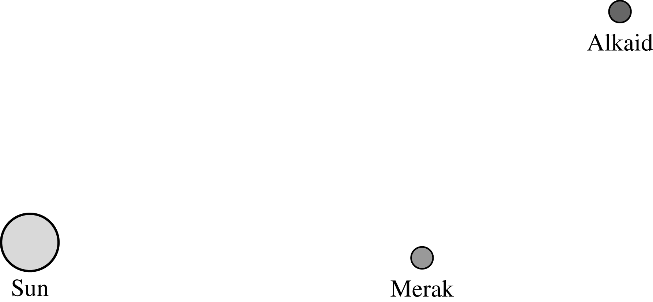

The law of cosines (see Problem 1.88) gives the distance as

where the supplement of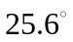has been used for the angle between the direction
vectors.
b) Although the law of cosines could be used again, it's far more convenient to use the law of sines (Appendix B), and the angle is given by

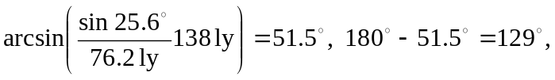
where the appropriate angle in the second quadrant is used.

